2. Frame Assembly

Vitamins
46 M4 cap screw x 16mm  2 Dibond sheet 166mm x 384mm x 3mm  1 Dibond sheet 465mm x 384mm x 3mm  1 Dibond sheet 465mm x 419mm x 3mm | 46 Nyloc nut M4  46 Washer M4 x 9mm x 0.8mm  25 Zip-tie 100mm min length

Printed parts
16 fixing_block.stl  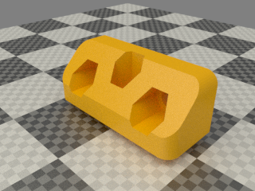 | 1 ribbon_clamp_26_44N.stl  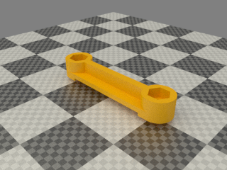
1 ribbon_clamp_20_44N.stl
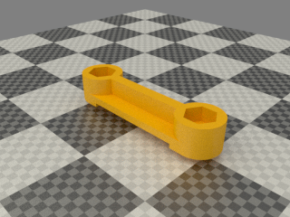

Assembly
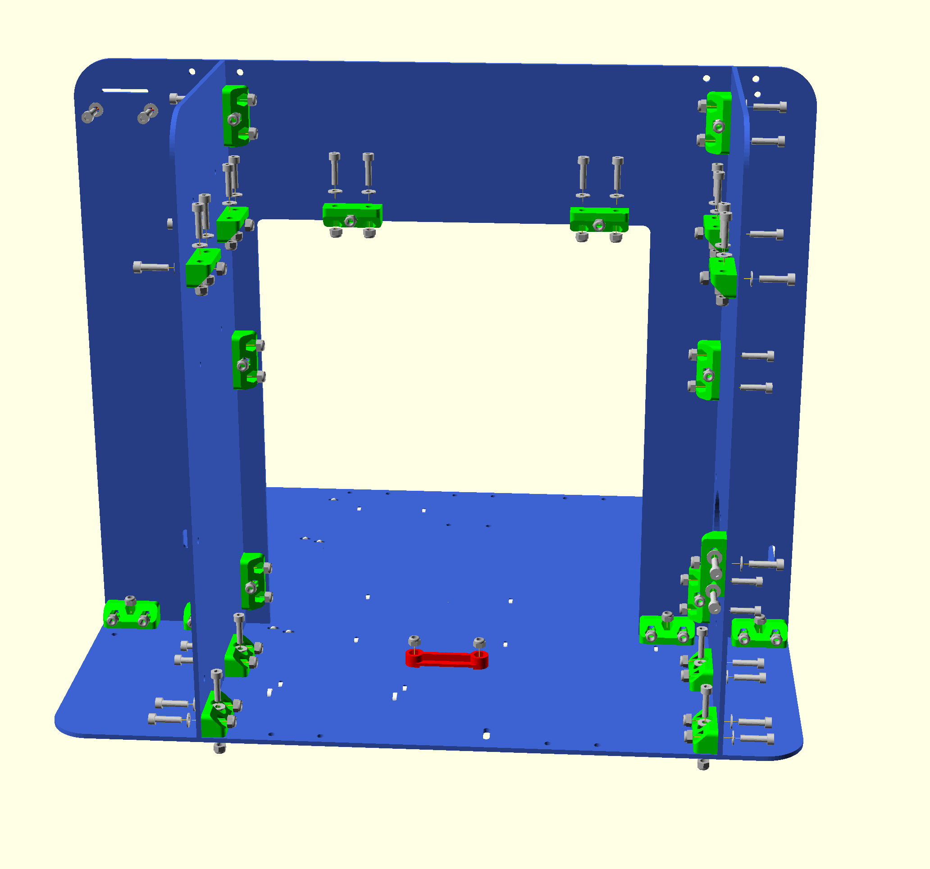
Note that this view is from the back of the machine. The 6 Blocks near the top are for the optional enclosure. The fixing block at the (on picture) right stay cloest to you is also for the optional enclosure. Not on the picture is also fixing block on the other stay, this one is also for the optional enclosure. While not needed this enclosure can help stiffen up the frame a great deal. It will also add a shelf where extruders for bowden setup can be added. There is also 2 more fixing blocks on the gantry above the 2 top most shown. This is because the frame had to be extended up as some direct drive extruders protude more than others. Without this extension it would not be possible to fit the enclosure.
- Remove the protective film from the Dibond panels. They all have a matt side and a shiny side. The shiny side is up on the base, forward on the gantry and outside on the stays.
- Insert M4 nyloc nuts into each of the three nut traps in the fixing blocks (a small pair of snipe nose pliers is useful for pressing them home).
TIP: You can also use the nose pliers to hold the nyloc while tighten the screws. Once they starts to seat in the fixing block you should be able to put down the pliers,
- Loosely attach ten fixing blocks to the left and right stays with two M4 x 16mm screws and washers each, noting that they go on the matt side that faces inwards.
- Stand each sheet on its edge on a flat surface and slide the block down to be flush with the edge before tightening the screws. Tighten just enough to nip the sheets together but don't over-tighten.
- Fit the remaining four fixing blocks along the bottom of the back of the gantry (large n shaped sheet) in the same way.
- Fix the stays to the back of the gantry using one screw in each fixing block. Note the shiny sides face outwards and the one with the fan hole is on the left hand side looking from the front. Tighten the screws.
- Loosely screw the gantry to the base using M4 x 16mm screws and washers from below into the nut traps in the fixing blocks.
- Loosely insert ties into the pairs of small holes in the right stay and base. (shown in white in the assembly view). The joins should be under the base and on the right stay towards the left stay.
- Loosely attach the two ribbon clamps. The longer one goes at the back of the base for the bed wires. The shorter one goes at the top of the gantry for the X axis cable.
- Use a square to check that all sheets stand on a 90 angle to each other. It can take some fiddle work to get them at right angles but the better the frame is the better and more easy the rest of the build will be.

